Add a Department

Functionality: This dialogue allows the user to add a Department to the Main Org. It allows the user to capture all information necessary for billing, contacting and tracking. The Add-a- Department Dialogue, in Physia, handles the majority of this. First a review of fields will be discussed and then the action codes will be discussed.

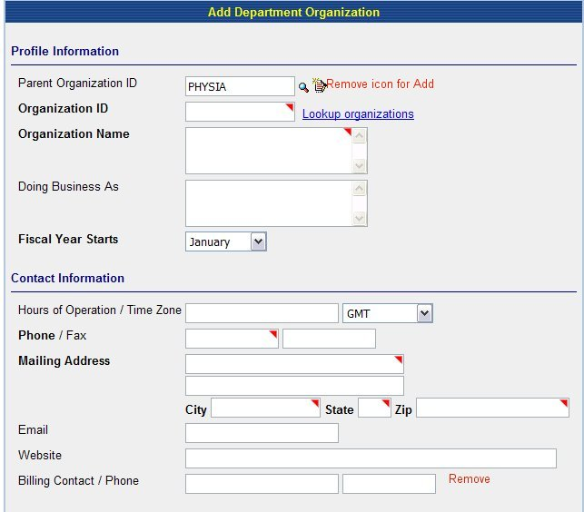
Fig 1a

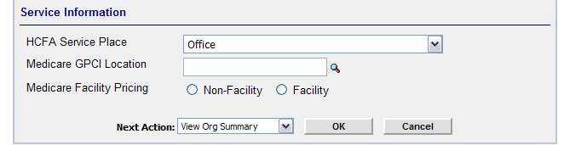

Fig 1b

Add:
- In Medspective, add the markers indicating required fields, in Physia this is the red triangle.
- In Medspective, add Look ups at Parent Org Id and Organization Id.

Remove:
- Billing Contact. (Fig 1a)
- Add button from Parent Org Id .

Edit:

- Main org Id should pull into Parent Org Id (as it does in Physia) Fig 1a
- Look up at Organization ID should either be a symbol or hyperlink of text and this form should be consistent throughout the application.
- Look up at Medicare GPCI location should follow the same rules as point b.
- Drop down at HCFA Service Type should include all HCFA places of services listed with Center for Medicare and Medicaid Services.

Action Codes

Look up a Parent Org Id: This lookup, whether an icon (magnifying glass or the words are a hyperlink) should take user to a search dialogue which allows the user to search for an existing organization. ***Note the method chosen for lookup should stay consistent throughout the application. **
When the user clicks the symbol or the hyperlink, it should take them to a search engine.

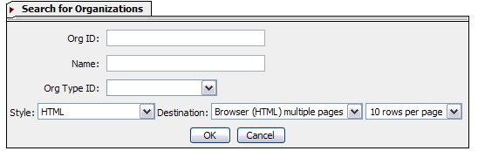

The results should consist of the following:

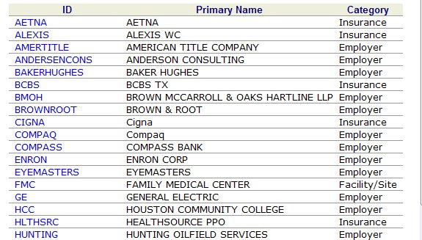
Fig 1c

Edit:
- Ensure that results are in alphabetical order by Primary Name.
- Change name of Category column to Type. (This is the name of the field in Add-Dialogue).
- The only items listed in Column 3 (Category) are Associate Providers and Main Org.
- When user clicks hyperlink, the application should pull that Org Id into the Parent Org Id Field.

Look up an existing Department ID: This lookup, whether an icon (magnifying glass or the words are a hyperlink) should take user to a search dialogue which allows the user to search for an existing Department ID. This should only list Associated orgs and the Main org.—see below. ***Note the method chosen for lookup should stay consistent throughout the application. **
When the user clicks the symbol or the hyperlink, it should take them to a search engine.

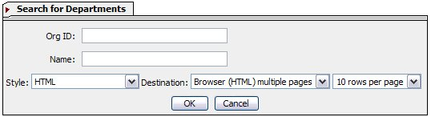

The results should consist of the following:

Fig 1c

Edit:
- Ensure that results are in alphabetical order by Primary Name.
- Change name of Category column to Type. (This is the name of the field in Add-Dialogue).
- The only items listed in Column 3 (Category) are Associate Providers, Departments and Main Org.
- When user clicks hyperlink, the application should pull Pop up a message stating, “ [Org ID] already exists.”→The user clicks [OK] and the application take the user to a blank Add-a-Department Dialogue.
- If the user does not see the org they requested→user closes results window→application takes user back to blank Add-a-Department Dialogue.

Next Action:

Once the user completes all necessary fields in Add-a-Department Dialogue, they should choose a Next Action (see below)

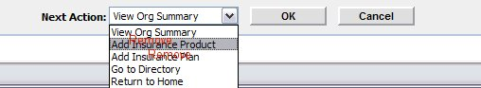
Fig 1c

Add:
- “Add another Department”
- “Go to Work List”

Edit:
Change “Go to Directory” to “Go to Search”

Remove:
- Add Insurance Product
- Add Insurance Plan

View Org Summary: Takes user to Organization Summary
Add another Department: Takes user to blank Add Department Screen
Go to Search: Takes user to Search engine for orgs
Return to Home: Takes user to their Home Page
Go to Work List: Takes user to Work List

Function:

User Clicks [OK] →Application suggests 3 Org Ids→Application should add an [OK] [Cancel] Button next to suggestions→User chooses Org Id→Clicks [OK]→ Application adds Organization and performs Next Action.

